Министерство образования Республики Беларусь

Учреждение образования

“Брестский государственный технический университет”

Кафедра интеллектуально-информационных технологий

Лабораторная работа №5

“ MLP. Прогнозирование”

Выполнил:

студент 3 курса

группы ИИ-22

Копанчук Е. Р.

Проверил:

Туз И. С.

Брест 2023

Написать нейронную сеть(multilayer perceptron c одним скрытым слоем) для

решения задачи прогнозирования функции:

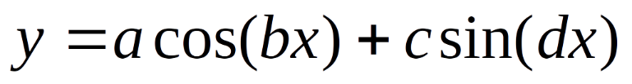

Обучить сеть с использованием константного и адаптивного шага обучения, online-

learning и batch-learning. Результаты для каждого варианта сети занести в таблицу(

test error, количество эпох, время обучения и тд)

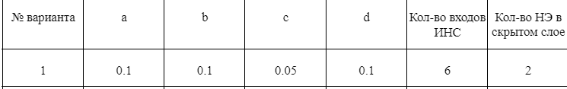

from matplotlib import pyplot as plt

import numpy as np

from scipy.special import expit

E_arr_arr = []

E_arr = []

f = lambda x : 0.1 * np.cos(0.5 * x) + 0.09 * np.sin(0.5 * x)

def normalize_data(data, min_val, max_val) :

min_data = np.min(data)

max_data = np.max(data)

normalized_data = (data - min_data) / (max_data - min_data) * (max_val - min_val) + min_val

return normalized_data

class Network :

def __init__(self, input_size, hidden_size, output_size, learning_rate = 0.01) :

self.input_size = input_size

self.hidden_size = hidden_size

self.output_size = output_size

self.learning_rate = learning_rate

self.start_learn_rate = learning_rate

self.weights_input_hidden = np.random.randn(self.input_size, self.hidden_size)

self.bias_hidden = np.random.randn(1, self.hidden_size)

self.weights_hidden_output = np.random.randn(self.hidden_size, self.output_size)

self.bias_output = np.random.randn(1, self.output_size)

def sigmoid(self, x) :

return expit(x)

def sigmoid_derivative(self, x) :

return x * (1 - x)

def forward(self, inputs) :

self.hidden_input = np.dot(inputs, self.weights_input_hidden) + self.bias_hidden

self.hidden_output = self.sigmoid(self.hidden_input)

self.output = np.dot(self.hidden_output, self.weights_hidden_output) + self.bias_output

return self.output

def predict(self, inputs) :

output = self.forward(inputs)

result = [el[0] for el in output]

return normalize_data(result, -0.13446, 0.13446)

def backward(self, inputs, target, output) :

error = target - output

delta_hidden = error.dot(self.weights_hidden_output.T) * self.sigmoid_derivative(self.hidden_output)

self.weights_hidden_output += self.hidden_output.T.dot(error) * self.learning_rate

self.bias_output += np.sum(error, axis = 0, keepdims = True) * self.learning_rate

self.weights_input_hidden += inputs.T.dot(delta_hidden) * self.learning_rate

self.bias_hidden += np.sum(delta_hidden, axis = 0, keepdims = True) * self.learning_rate

def backwardBatch(self, inputs, targets, outputs) :

error = targets - outputs

mse_batch = np.sum(error) / len(error)

inputs_cut = 0

for j in range(len(error)) : inputs_cut += error[j] * inputs[j]

mse_batch = np.array(mse_batch)

inputs_cut = np.array(inputs_cut).reshape(1, -1)

delta_hidden = mse_batch.dot(self.weights_hidden_output.T) * self.sigmoid_derivative(self.hidden_output)

self.weights_hidden_output += self.hidden_output.T.dot(mse_batch) * self.learning_rate

self.bias_output += np.sum(mse_batch, axis = 0, keepdims = True) * self.learning_rate

self.weights_input_hidden += inputs_cut.T.dot(delta_hidden) * self.learning_rate

self.bias_hidden += np.sum(delta_hidden, axis = 0, keepdims = True) * self.learning_rate

def train(self, inputs, targets, epochs: int, isAdapt : bool = False) :

global E_arr

for epoch in range(epochs) :

e_arr = []

for i in range(len(inputs)) :

input_data = np.array([inputs[i]])

target_data = np.array([targets[i]])

output = self.forward(input_data)

e_arr.append(targets[i] - output)

self.backward(input_data, target_data, output)

E2 = np.sum(np.array(e_arr) * *2) / 2

E_arr.append(E2)

self.learning_rate = min(0.2, max(self.learning_rate * E2, 0.0046)) if isAdapt else self.learning_rate

#print(f"Online: Epoch: {epoch} MSE: {E2}")

def trainBatch(self, inputs, targets, epochs: int, batchsize : int, isAdapt : bool = False) :

global E_arr

if (len(inputs) % batchsize != 0) : return ValueError

inputspack = [inputs[i - batchsize:i] for i in range(batchsize, len(inputs), batchsize)]

targetspack = [targets[i - batchsize:i] for i in range(batchsize, len(targets), batchsize)]

for epoch in range(epochs) :

e_arr = []

for i in range(len(inputspack)) :

outputs = [self.forward(batchElem).item() for batchElem in inputspack[i]]

e_arr.append(np.mean(targetspack[i] - outputs))

self.backwardBatch(inputspack[i], targetspack[i], outputs)

E2 = np.sum(np.array(e_arr) * *2) / 2

E_arr.append(E2)

self.learning_rate = min(0.2, max(self.learning_rate * E2, 0.0046)) if isAdapt else self.learning_rate

#print(f"Batch: Epoch: {epoch} MSE: {E2}")

def get_train_data(all_points, input_size) :

result_X = [all_points[i:i + input_size] for i in range(len(all_points) - input_size)]

result_Y = [all_points[i] for i in range(input_size, len(all_points), 1)]

return np.array(result_X), np.array(result_Y)

input_size = 8

hidden_size = 3

output_size = 1

epochs = 100

all_train_points = f(np.arange(100, 200, 0.2))

all_test_points = f(np.arange(180, 280, 0.2))

X_train, Y_train = get_train_data(all_train_points, input_size)

X_test, Y_test = get_train_data(all_test_points, input_size)

def cutVer(E_arr, epochs, all_train_points, predicted, start, end) :

print(f"Time taken: {(end-start)*10**3:.03f}ms")

print(min(E_arr))

plt.plot(range(0, epochs), E_arr)

plt.show()

plt.plot(np.arange(100, 200, 0.2), all_train_points)

plt.plot(np.arange(181.6, 280, 0.2), predicted, ":")

plt.show()

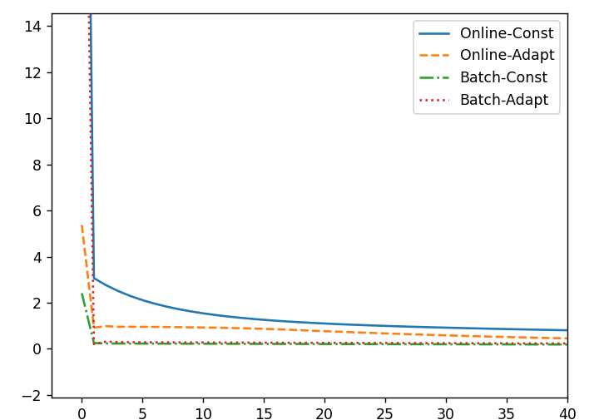

Вывод: изучил обучение и функционирование ИНС при решении задач прогнозирование.